MODULE 4: Model View Controller Pattern
Contents
- Model-View-Controller (MVC) Pattern 1
- Commands as Methods 1
- Commands as Objects 2
- Implementing Object-Oriented Language Features in Java 2

Model-View-Controller (MVC) Pattern
The MVC pattern is a software architectural pattern used to build applications by separating the concerns of data, user interface, and user input. It promotes modularity, making the codebase easier to maintain, test, and scale. Components of MVC
- Model: Represents the application’s data and business logic. Responsibilities:
  - Manages the data and application state.
  - Performs operations like database access, calculations, and business rule enforcement.
  - Notifies the view when the data changes.
Example: In a library app, the Book class can represent a model containing attributes like title, author, and availability.

- View: Represents the user interface (UI) of the application. Responsibilities:
  - Displays the data from the model to the user.
  - Listens for updates from the model and refreshes the UI.
  - Does not directly interact with the model.
Example: In a GUI application, the JTable or TextField components displaying book data act as the view.

- Controller: Acts as an intermediary between the view and the model, handling user inputs and triggering updates. Responsibilities:
  - Processes user input from the view.
  - Updates the model based on user actions.
  - Notifies the view to refresh its display after changes in the model.
Example: In the library app, clicking a "Borrow Book" button triggers the controller to update the book's availability in the model.

- Separation of Concerns: Each component (Model, View, Controller) focuses on a specific concern, improving modularity. Benefits:
  - Maintainability: Changes to the UI (view) don’t affect business logic (model) and vice versa.
  - Scalability: Easier to add features or modify individual components.
  - Testability: Components can be tested independently.
Example: If a new user interface is required (e.g., switching from Swing to JavaFX), the view can be replaced without altering the model or controller.

Flow in MVC
- User interaction: The user interacts with the view (e.g., clicks a button).
- Controller processes input: The controller processes the input and updates the model.
- Model changes state: The model updates its data and notifies the view.
- View updates: The view reflects the changes in the model.

Commands as Methods
- Definition: Actions or operations are encapsulated as individual methods within classes.
- Features:
  - Direct execution of commands through method calls.
  - Suitable for small, simple applications where the action logic is straightforward.
- Benefits:
  - Simplicity: Easy to implement and understand.
  - Minimal overhead: No need for additional structures like objects.
- Drawbacks:
  - Tight coupling: The caller and the receiver are closely linked, making it less flexible for complex applications.
  - Difficult to extend: Adding new commands requires modifying the existing code.

Commands as Objects
- Definition: Encapsulates requests as separate objects, decoupling the sender (invoker) and the receiver (executor). This is a core concept of the Command Pattern.
- Features:
  - Each command is represented as a class implementing a common interface (e.g., Command with execute()).
  - Enables queuing, logging, undo/redo operations, and parameterization of commands.
- Benefits:
  - Decouples sender and receiver, improving flexibility and scalability.
  - Supports advanced features like undo/redo.
- Drawbacks:
  - Increased complexity: More classes and structures are needed.
  - Slightly higher memory overhead due to object creation.

Aspect | Commands as Methods | Commands as Objects
Definition | Encapsulates actions as methods. | Encapsulates requests as objects.
Complexity | Simple and minimal overhead. | More complex due to multiple classes.
Flexibility | Less flexible; tightly coupled. | Highly flexible; decouples sender/receiver.
Scalability | Limited for large applications. | Scales well for advanced functionality.
Use Case | Small and straightforward operations. | Queuing, logging, undo/redo functionality.

Implementing Object-Oriented Language Features in Java
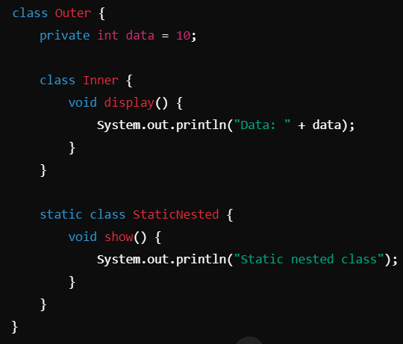
Java-Specific Features
- Inner Classes (Static and Non-Static): Inner classes are classes defined within another class, useful for logically grouping classes or for implementation of event listeners. Types:
    - Non-static Inner Classes: Have access to instance variables of the outer class.
    - Static Nested Classes: Can be instantiated without an instance of the outer class.

- Anonymous Classes and Lambda Expressions
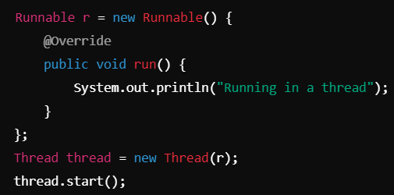
  - Anonymous Classes: Classes with no name, defined in a single expression, often used for implementing interface methods.

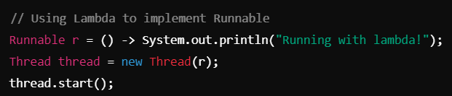
  - Lambda Expressions: Concise way to express instances of functional interfaces (interfaces with a single abstract method).

- Functional Interfaces (Consumer, Predicate, etc.): An interface with a single abstract method, used with lambda expressions. Common Functional Interfaces:
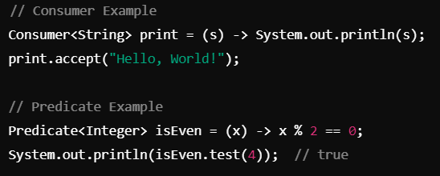
    - Consumer: Takes a single input and performs an action (e.g., forEach()).
    - Predicate: Takes a single input and returns a boolean.
    - Function: Takes an argument and returns a result.

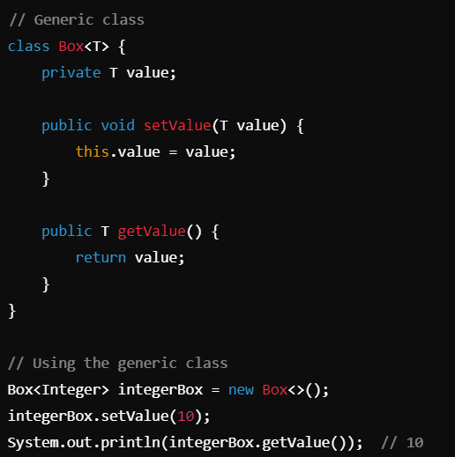
- Generics (e.g., List<T> and Custom Generic Classes): Generics allow you to create classes, methods, and interfaces that can operate on objects of various types while providing compile-time type safety. How to Implement: Use type parameters (e.g., T, E, K, V) in class, interface, or method declarations.

